**Recognizing Phases and Phase Transitions by Unsupervised and Supervised Machine Learning**

Jairo J. Orozco1, Alejandro Rigau1 Junqiang Lu1

*1Deparment of Physics, University of Puerto Rico Mayagüez Campus, 00680 PR USA*

Machine learning has become a robust method for the identification of patterns when you have a certain amount of data and has helped to find properties and physical quantities of certain physical systems, without the need to know the physical properties that describe the system. In this paper we applied unsupervised machine learning called Principal Component Analysis (PCA) to square and hexagonal Ising model, to identify phases and phase transition. We found that PCA allow us to identify this phase transitions and located the critical points for both systems, we shown that the firsts principal components are related with physical properties of the model as the order parameter and the susceptibly of the systems. The weights vectors have a physical explanation which is helpful to get a better understanding of the behavior of the systems.

1. **INTRODUCTION**

In recent years, machine learning has been a powerful tool to discover new physics without prior human knowledge and especially complex problems in physics.

This means that we can know for example, how a physical system behaves without even knowing its Hamiltonian. What machine learning does is to enable computers to learn from various experiences, events or data, once the computer learns, it allows generalizing the knowledge learned to later solve problems without knowing the basis of the problem.

In the field of physics, machine learning has had a great impact, through the different supervised and unsupervised machine learning techniques; it has been possible, for example, to predict crystal structures. [2], to approximate density functions [3], to modeling molecular atomization energy [4] and there are many other applications.

In supervised machine learning, we have a data set and we already know what our correct outputs should looks like, there is a relationship between the input and the output, to this output we called labels. Unlike this, unsupervised machine learning allows us to approach problems with no idea of what our results should looks like; we can make predictions of a certain problem without knowing the labels by clustering the data, based in the relationship among the variables in the data[curso].

Classifying and discovering phase and phase transitions is one of the most important topics of Condensed Matter Physics [1], however, it is not an easy job to do, and above all, when we work with complex systems and the number of states is very large.

The Ising model has been used for a long time. This model is one of the most important in the theoretical physics, given that it was the first model that could successfully predict a phase transition [5].

Recently, the Monte Carlo method has been used together with the machine learning techniques [1, 6, 7] for the study and discovery of phases and phase transitions, the Monte Carlo method is used for the creation of data, which will be used to implement the techniques of machine learning, this method is used to calculate numerically the thermodynamic properties, that is, averages in a system by numerical simulations. The idea of the method is to find an algorithm to generate a long sequence of configurations of a system, such that after a while, each configuration is generated with the appropriate probability to describe the equilibrium of the system [8].

In this paper we applied unsupervised machine learning PCA (Principal Component Analysis) technique to hexagonal ferromagnetic Ising model systems, in order to recognize phases and phase transitions and its physical properties without any information about the microscopic theory or the order parameter in the different arrangements. We studied first the well understood Ising model in square lattice as our toy model, once it was studied, we applied PCA in hexagonal lattice to later compare results.

PCA was able to recognize the phase transition in both system and make a good approximation of the critical temperature Tc. In this paper we will figure out what PCA can do and find the physics answer of this machine learning method.

1. **MODEL**

We implemented the classical Ising model of phase transition. The 2D Ising model phase transition with ferromagnetic interaction (J>0) has been mostly studied in square and triangular lattices [6,9], the square lattice has the paramagnetic to ferromagnetic phase transition at the critical temperature [10,5].

${ T}_{c}=2J/K_{B}ln⁡(\sqrt{2}+1)=2.2692(J{/K}_{B})$ (1)

In this paper, it was first studied as a toy model the two-dimensional square-lattice Ising model with no magnetic field and with periodic boundary conditions

$H=-J\sum_{<i,j>}{S_{i}S_{j}}$ (2)

Where $S_{i}=±1$ and $J=1$ between the four nearest neighbors.

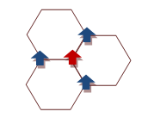

Figure 1: Schematics for the spins interaction of the hexagonal lattice.

The next step was implementing the Ising model in hexagonal lattice with ferromagnetic interaction, choosing again *J=1*. For the structure of the system, each spin ($S_{i}=±1$) interact with three nearest neighbors as shown in figure 1. The Hamiltonian that describe this system is written as

$H=-J\sum_{i=1}^{M}{\sum_{j=1}^{N}{S_{i,j}}S_{i+1,j}}$ (3)

For the hexagonal lattice, a phase transition to an ordered state occurs when the temperature T is reduced below the critical value [11].

${ T}_{c}=2J/K_{B}ln⁡(2+\sqrt{3})=1.519(J{/K}_{B})$ (4)

1. **METHOD**

For this paper, we generated spin configuration samples using Monte Carlo simulation [reference], for square lattice we collected 300 for each temperature, *T/J*=3.5,3.4, … ,0.8, and for hexagonal lattice we collected the same amount as the square lattice at temperatures of *T/J*=3.0,2.9, … ,0.3, with a *∆T=0.1*. This was the only data that we used to feed the unsupervised learning algorithm.

We implemented Principal Components Analysis (PCA) as machine learning technique to recognize phases and phase transitions, this is an unsupervised learning algorithm for identify patterns in data of high dimensions. PCA is a powerful tool for compress your data to small dimensions without much loss of information [12].

We collect data by Monte Carlo simulation in a matrix **S** with dimensions MxN, where M=*nT*, *T* is the number of different temperatures and*n* is the number of configurations under the same temperature. Each row of the matrix will be a configuration sample.

Once we have the matrix **S**, the next step is to apply PCA. **S** has to be centered subtracting the mean value $m_{ij}=(1/M)\sum_{i}{S_{ij}}$ of each column and the values from the entries in the column to get the matrix **X.**

The PCA finds the principal components through a transformation vector of the original data.

𝑌 = **𝑋**𝑊 (5)

For our case, the PCA will find or identify patterns in the data with the change of temperature. The main goal of PCA is to find out one or a few directions where you can distinguish all the data sets with a few losses of information. This is equivalent to searching for the maximum variance in which the data is distributed.

The orthogonal transformation is due the vectors W = (w1; w2; …; wN), where w’s are called weights, the first weight is found by

${ w}_{1}={\arg{max}}_{\left\|w\right\|=1}\left\{\sum_{i}{{(x_{i}.w)}^{2}}\right\}$ (6)

Instead do this, we will find out the eigenvector corresponding to the largest few eigenvalues of the matrix 𝑿𝑻(𝑐𝑜𝑣𝑎𝑟𝑖𝑎𝑛𝑐𝑒).

$X^{T}Xw_{n} = λ_{n}w_{n}$ (7)

The principal components are calculated as

$P_{n} = Xw_{n}$ (8)

Where ***w1*** will be the vector corresponding to the largest variance, it means the larger eingenvalue.

Our results are in base of the ‘quantified principal components’ that are defined as the average.

$〈\left|P_{n}\right|〉=1/n\sum_{n}{\left|P_{n}\right|}$ (9)

We will show that our results from PCA are consistent with the model and the different lattices.

Figure 2: a) PCA first explained variance ratios from the Ising configurations for square lattice. b) Weights of the first principal component for each lattice size for square lattice. c) PCA first explained variance ratios from the Ising configurations for hexagonal lattice. b) Weights of the first principal component for each lattice size for hexagonal lattice.

1. **RESULTS**

We studied the square lattice system as a toy model, to compare results with other authors […] and was the base to study the hexagonal lattice system, in our case we will focus in the results of the ferromagnetic hexagonal system.

Fig…, shows the results of the hexagonal lattice system, it clearly shows one dominant principal component for the different lattice sizes and the Fig. .. shows a constant weight vector corresponding to this principal component. Notice that w1⋍1/L, this result mean that, with the first principal component it was identified the order parameter which correspond to the magnetization of the system. Following the Eq. (8) and taking a given configuration from one of the rows of **X** we get,

$P_{1} =\frac{1}{L}\left[s_{1},s_{2},s_{3}…\right]\left[\begin{aligned}1 \\ 1 \\ 1 \\ …\end{aligned}\right]= \frac{1}{L}\sum_{i=1}^{N}{s_{i}}$ (10)

Similar results show the square lattice system in [..], which also have one dominant main component and a constant W1 in the different lattice sizes.

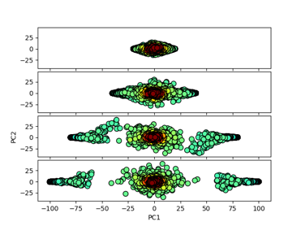

Figure 3: projection of the spin configurations onto the plane for the two principal components for the hexagonal system configuration.

Fig. 3 shows the spin configurations in a two-dimension spanned plane by the two first principal components in hexagonal lattice, we see three different clusters, the points close the origin corresponds to the spin configuration above the critical temperature Tc and the separate other two regions corresponds to the spin configurations below this critical temperature. With this result PCA shows that there is a phase transition.



Figure 4: a) The normalized quantified first leading component versus the temperature for hexagonal lattice. b) The normalized quantified second leading component versus temperature for hexagonal lattice.

In Fig. 4a and 4c were plotted the quantified first leading component over the system size L <p1>/L versus the temperature, in order to mimic the magnetization in the two lattices type.

$m=\frac{1}{N}\sum_{i=1}^{N}{s_{i}}= \frac{{<P}_{1}>}{L}$ (11)

Where $m$ is the magnetization and $N=L x L$.

Increasing the size of the system, you can better appreciate the phase transition, approaching the theoretical value represented with the dash line.

The Fig. 4b and 4d are the plot of quantified second leading component over the system size L, <p2>/L versus temperature, in this case represent the behavior of susceptibility for the systems (χ).

Figure 5:Critical temperatures taken from the maximums of Fig. 4 versus the inverse of the lattice size.

Follow the treatment in (13) using the square lattice system, based in the second leading component and using the scaling relation in thermodynamic limit

$T_{c}^{'}=T_{c}+ {KL}^{-1}$ (13)

Where $T_{c}^{'}$ is the maximum of the susceptibility 𝜒, $T_{c}$ and $K$ are the fit parameters.

We could get an approximation of the critical temperature tc, plotting the maximums in Fig. 4 versus the inverse of the system size 1/L, the intercept of the fit for hexagonal lattice is, see Fig. 5:

Tcs = 2.25

Tch = no yet calculated

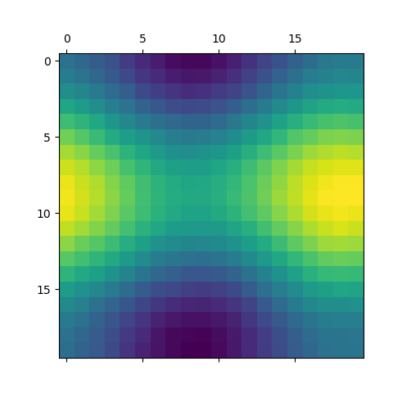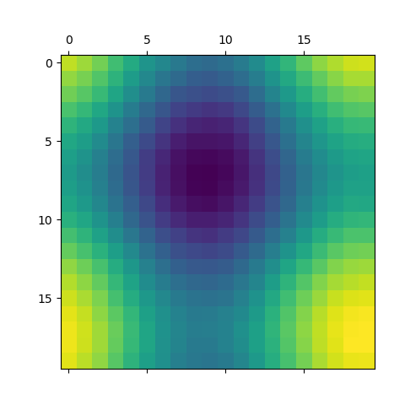

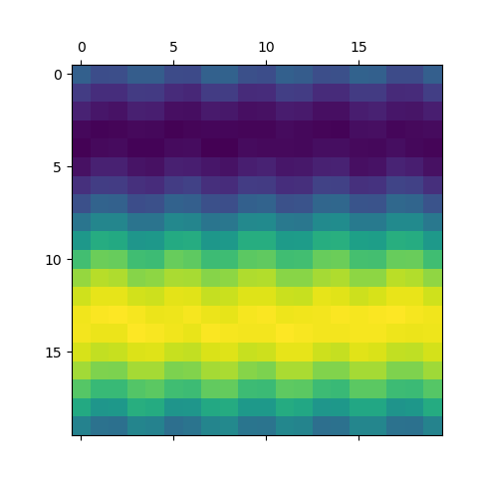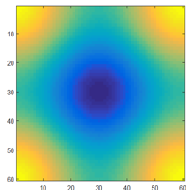

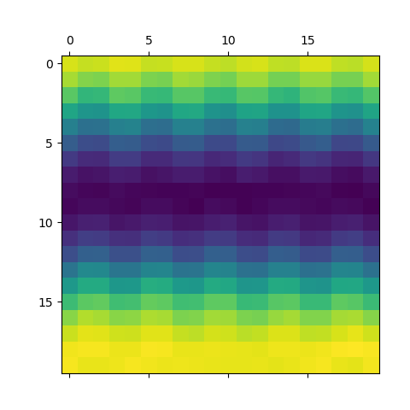

Figure 6: a) and b) Are the weighs for the second and third component respectively, plotted on the square lattice L=20. C) and d) Are the weighs for the second and third component respectively, plotted on the hexagonal lattice L=20. e) plot of $W_{2}^{,}$, this plot is compared by its similarity with a).

Fig. 6a and 6b show the weights for the second and third components plotted on the square lattice using 7000 samples per temperature, Fig 6a is compared in (9) with Fig. 6d that is a plot of

$$W_{2}^{,}=\frac{1}{L}[\cos\left(r_{1}k_{1}\right),…, \cos\left(r_{N}k_{1}\right)]$$

$+\frac{1}{L}[\cos\left(r_{1}k_{2}\right),…, \cos\left(r_{N}k_{2}\right)]$ (13)

where *ri* is the lattice site and k1 = (0, 2𝜋/L), k2 =(2𝜋/L,0) are the lowest Fourier wave vectors. They associated the first component with the origin k0= (0,0).

They determined that for ferromagnetic Ising model in square lattice PCA is building up weight vectors which corresponding to the Fourier modes of the spin configurations.

The results of the weight for the second component plotted on the hexagonal lattice were different from the square lattice, see Fig. 5c. If we follow the same explanation of (9) we could say that for the hexagonal Lattice system, we found different Fourier modes of the spin configuration.

References

[1] L. Wang, *Discovering Phase Transitions with Unsupervised Learning.* Beijing National Lab for Condensed Matter Physics and Institute of Physics, Chinese Academy of Sciences, Beijing 100190, China (2016)

##### [2] K. T. Schütt, H. Glawe, F. Brockherde, A. Sanna, K. R. Müller, and E. K. U. Gross, Phys. Rev. B 89, 205118 (2014).

[3] J. Snyder, M. Rupp, K. Hansen, K. Muller, and K. Burke. Physical review letters, 108, 253002 (2012).

### [4] M. Rupp, A. Tkatchenko, K. Müller, and O. Anatole von Lilienfeld, Phys. Rev. Lett. 108, 058301 (2012).

[5] L. Onsager.  *A two- dimensional model with an order-disorder transition*, Physical Review 65 117 (1944).

[6] C. Wang and H. Zhai Machine learning of frustrated classical spin models. I. Principal component analysis, physical review B 96, 144432 (2017)

[7] S. Wetszel, Unsupervised learning of phase transitions: from principal component analysis to variational autoencoders, Phys. Rev. E, 96, 022140 (2017).

[8] D. Sanders Introducción a las transiciones de fase y a su simulación, Universidad Nacional Autónoma de México.

[9] W. Hu, R. Singh and R. Scalettar, Discovering Phases, Phase Transitions and Crossovers through Unsupervised Machine Learning: A critical examination, Phys. Rev. E 95, 062122 (2017).

[10] S. Yeon Kim, World Academy of Science, Engineering and Technology 59 (2011).

[11] Stephen L. Eltinge, Massachusetts Institute of Technology, 77 Massachusetts Ave., Cambridge, MA 02139-4307, (2015)

[12] Lindsay I Smith, A tutorial on Principal Components Analysis, (2010).

[curso] machine learning course coursera, buscar page

[13] A. Rebelo, Unsupervised learning of physical models: Uses and limitations of Principal Components Analysis, master thesis, Institute of Theorical Physics, (2017).

[14] B. M. McCoy and J.-Marie Maillard The Importance of the Ising Model Progress of Theoretical Physics, Vol. 127, No. 5, May 2012